
Applied Science Private University
Faculty of Information Technology

Graduation Project Report

Food Makers

Prepared by:

Mohammed Hamdan
Omar Khaled
Ibrahim Abdel lateif
Hayat Akiela

Supervised by:

Dr. Mohammed Khader

Jun 2023

Copyright © 2021-2022 Applied Science Private University. All rights are reserved
We certify that the work and ideas presented in this project is our own unless referenced.

Name and Signature: Mohammed Hamdan…… Date: 30.05.2023
Name and Signature: Omar Khaled……. Date: 30.05.2023
Name and Signature: Ibrahim Abdel Lateif…… Date: 30.05.2023
Name and Signature: Hayat Akiela……. Date: 30.05.2023

Contents
List of Figures iii
List of Tables iv
List of Symbols v
Abstract vi
Chapter 1: Introduction 7
1.1 Description of the current situation and opportunity 7
1.2 Related work 7
1.3 Problem statement (limitation of current systems) 8
1.4 Problem solution 8
1.5 Project objectives 8
1.6 Technology and tools used 9
1.7 Project Plan (Gantt chart, PERT chart) 10
Chapter 2: Requirements and Analysis 12
2.1 Software Process Model 12
2.2 System scope with explanation 12
2.3 Functional Requirements & Non-Functional Requirements 13
2.4 Use Case Diagram with Use Cases descriptions 15
2.5 Activity Diagram 21
Chapter 3: Design 24
3.1 Sequence Diagrams 24
3.2 Class Diagram 25
3.3 Database ER Diagram 27
Chapter 4: System Implementation 28
4.1 Main System Screenshots 28
4.2 Important code fragments 37
4.3 List of Non-Implemented requirements and reasons 49
Chapter 5: System Evaluation 50
5.1 System Testing 50
5.2 System Evaluation 52
Chapter 6: Conclusion & Future Work 52
6.1 Conclusion 52
6.2 Future work 52
References 53
Appendix Error! Bookmark not defined.

List of Figures

Figure 1. Gantt Chart 10
Figure 2. Gantt Chart 11
Figure 3. Scrum process framework 12
Figure 4. Use Case Diagram 15
Figure 5. Activity Diagram 22
Figure 6. Activity Diagram 23
Figure 7. Activity Diagram 24
Figure 8. Sequence Diagram 25
Figure 9. Class Diagram 26
Figure 10. Database ER Diagram 27
Figure 11. Registration Screen 28
Figure 12. Login Screen 29
Figure 13. Home Screen 30
Figure 14. Mechanical Screen 31
Figure 15. Handyman Profile Screen 32
Figure 16. Search Screen 33
Figure 17. Following Screen 34
Figure 18. User Screen 35
Figure 19. Update Profile Screen 36
Figure 20. Main Page 37
Figure 21. Cubit Page 38
Figure 22. Cubit Page 39
Figure 23. Home Page 40
Figure 24. Login Page 41
Figure 25. Login Page 42
Figure 26. Edit Profile Page 43
Figure 27. Edit Profile Page 44
Figure 28. Edit Profile Page 45
Figure 29. Category Page 46
Figure 30. Setting Page 47
Figure 31. Setting Page 48

List of Tables
Table 1. Use Cases descriptions (Create Account) 16
Table 2. Use Cases descriptions (Login) 16
Table 3. Use Cases descriptions (Forget Password) 17
Table 4. Use Cases descriptions (Display Categories) 17
Table 5. Use Cases descriptions (Pick a Handyman) 18
Table 6. Use Cases descriptions (Update List) 18
Table 7. Use Cases descriptions (Check viewed profiles) Error! Bookmark not defined.
Table 8. Use Cases descriptions (Search) Error! Bookmark not defined.
Table 9. Use Cases descriptions (Home Page) Error! Bookmark not defined.
Table 10. Use Cases descriptions (Chat) Error! Bookmark not defined.
Table 11. Use Cases descriptions (Upload) Error! Bookmark not defined.
Table 12. Use Cases descriptions (Update) Error! Bookmark not defined.
Table 13. Login Test 50
Table 14. Registration Test 50
Table 15. Update Profile Test 51
Table 16. Add Category Test 51
Table 17. Search Test 51

List of Symbols

Symbols | Meaning

Abstract

Abstract

A person's need for food is not just an option for him, but rather an essential component of his body, and perhaps this is the reason that urges people to search for healthier and safer food sources, and given the great importance of food, we have created the Food Makers application, which is a platform for entrepreneurs and housewives Homes to display their projects in an easier way. At the same time, many entrepreneurs face many problems in presenting their projects and the foods they offer.
The main objective of this application is to provide customers with an application that allows them to find their food orders easily and to help entrepreneurs and housewives promote themselves.

Chapter 1: Introduction
The idea for this application emerged from the growing demand for homemade food that is not being marketed effectively. The application serves as a bridge between homeowners operating kitchens and customers seeking access to these homemade meals. Our goal is to provide a supportive and motivating platform that will assist in increasing kitchen sales and aid owners in properly integrating into the growing market.

Description of the current situation and opportunity

In the 21 century and in the whole world where most people work in jobs with tight time schedules and crowded courses of life. People started for looking for alternative of cooking at home or preparing meals daily so people started consuming fast food and unhealthy lifestyle which is not the food that you need to have a healthy lifestyle, and always in the searching for alternative that could be healthy, trusted and clean at the same time, and we look for a good service and easy in the same time as well.
And now the local business and the home cooks who are looking for an opportunity to show their product on a larger scale of people in an easy way without the consequences of need of outsource company to help with advertisement or opening a restaurant , so people and entrepreneurs started to look for a way to sell their product and represent it in an easy and trusted way in a mobile app that is specialized in selling food for home cooks and small business and directed to a group of people that ,at the looks for this type of product and saves them time and effort , at the same time they are getting a trusted , healthy and decently priced food.
Therefore, our app introduces an interface that’s easy to use and could help to enhance the homemade food marketing and the entrepreneurs in Jordan.

Related work

Yumist: Founded in 2014 and headquartered in Gurgaon, India, Yumist offers home-cooked meals delivered in less than 30 minutes. Orders are taken through their app available in both Android and iOS as well as on their website. Customers can select from a menu offered by local chefs and home cooks. Orders are guaranteed fresh, delicious, and prepared with great consideration for cleanliness and hygiene. The menu changes every day, so users won’t have to order from the same set of menus.

WatsCooking: Funny nomenclature aside, the Watscooking app has many people buzzing with interest. Same with their other competitors, they offer home-cooked meals delivered to customers fresh and delicious. They also tap home chefs and hobbyists who want to make a profit out of their passion for cooking. Their focus is more on traditional home-cooked meals and their target audience is those with a full schedule and no time to prepare their own meal. Affordable and clean, Watscooking is getting a significant market share in the food ordering and delivery industry.

Problem statement (limitation of current systems)

The mentioned applications are not available in our region and have no alternative. Some sellers sell their products through social networking applications such as Instagram and Facebook, which are not intended for this purpose.
Instagram is not a platform dedicated to selling food, and people need to make ads, and they must collect followers in order for their business to succeed

Problem solution

We are currently developing an application that provides individuals with the capability to let away social networking platforms that are not exclusively designed for the purpose of selling food.
All of the aforementioned applications are currently unavailable in this region, and our primary objective is to develop an application that caters to the specific requirements of home cooks

Project objectives

The main objective of this project is to have a great app which is easy to use and practical for home cooks and local food business that can help them in getting an opportunity and in the other hand give people who are looking for healthy, tasty and safe home cooked food an app which in our case we are working on developing and to achieve that we will:
• Gather detailed Information and Define Requirements.
• Design system component.
• Build, test and integrate system component.
• Complete systems tests and deploy the project.

Technology and tools used
The technologies that will be used in this project are Flutter, SQL and ASP.net.

Project Plan (Gantt chart, PERT chart)

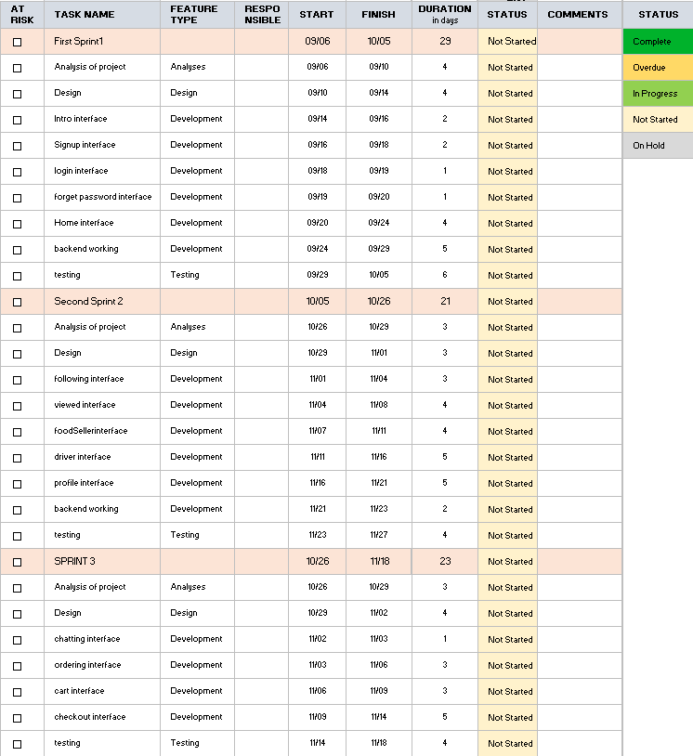
Figure 1. Gantt Chart

Figure 2. Gantt Chart

Chapter 2: Requirements and Analysis

Software Process Model
The used software process model is agile, adopting the Scrum process framework. The roles of the team will be the product owner, the development team, and the scrum master. The project will be divided into sprints. Each sprint will be considered a project with no more than a one-month horizon. After each sprint we will discuss any problem that face us to make changes on it.
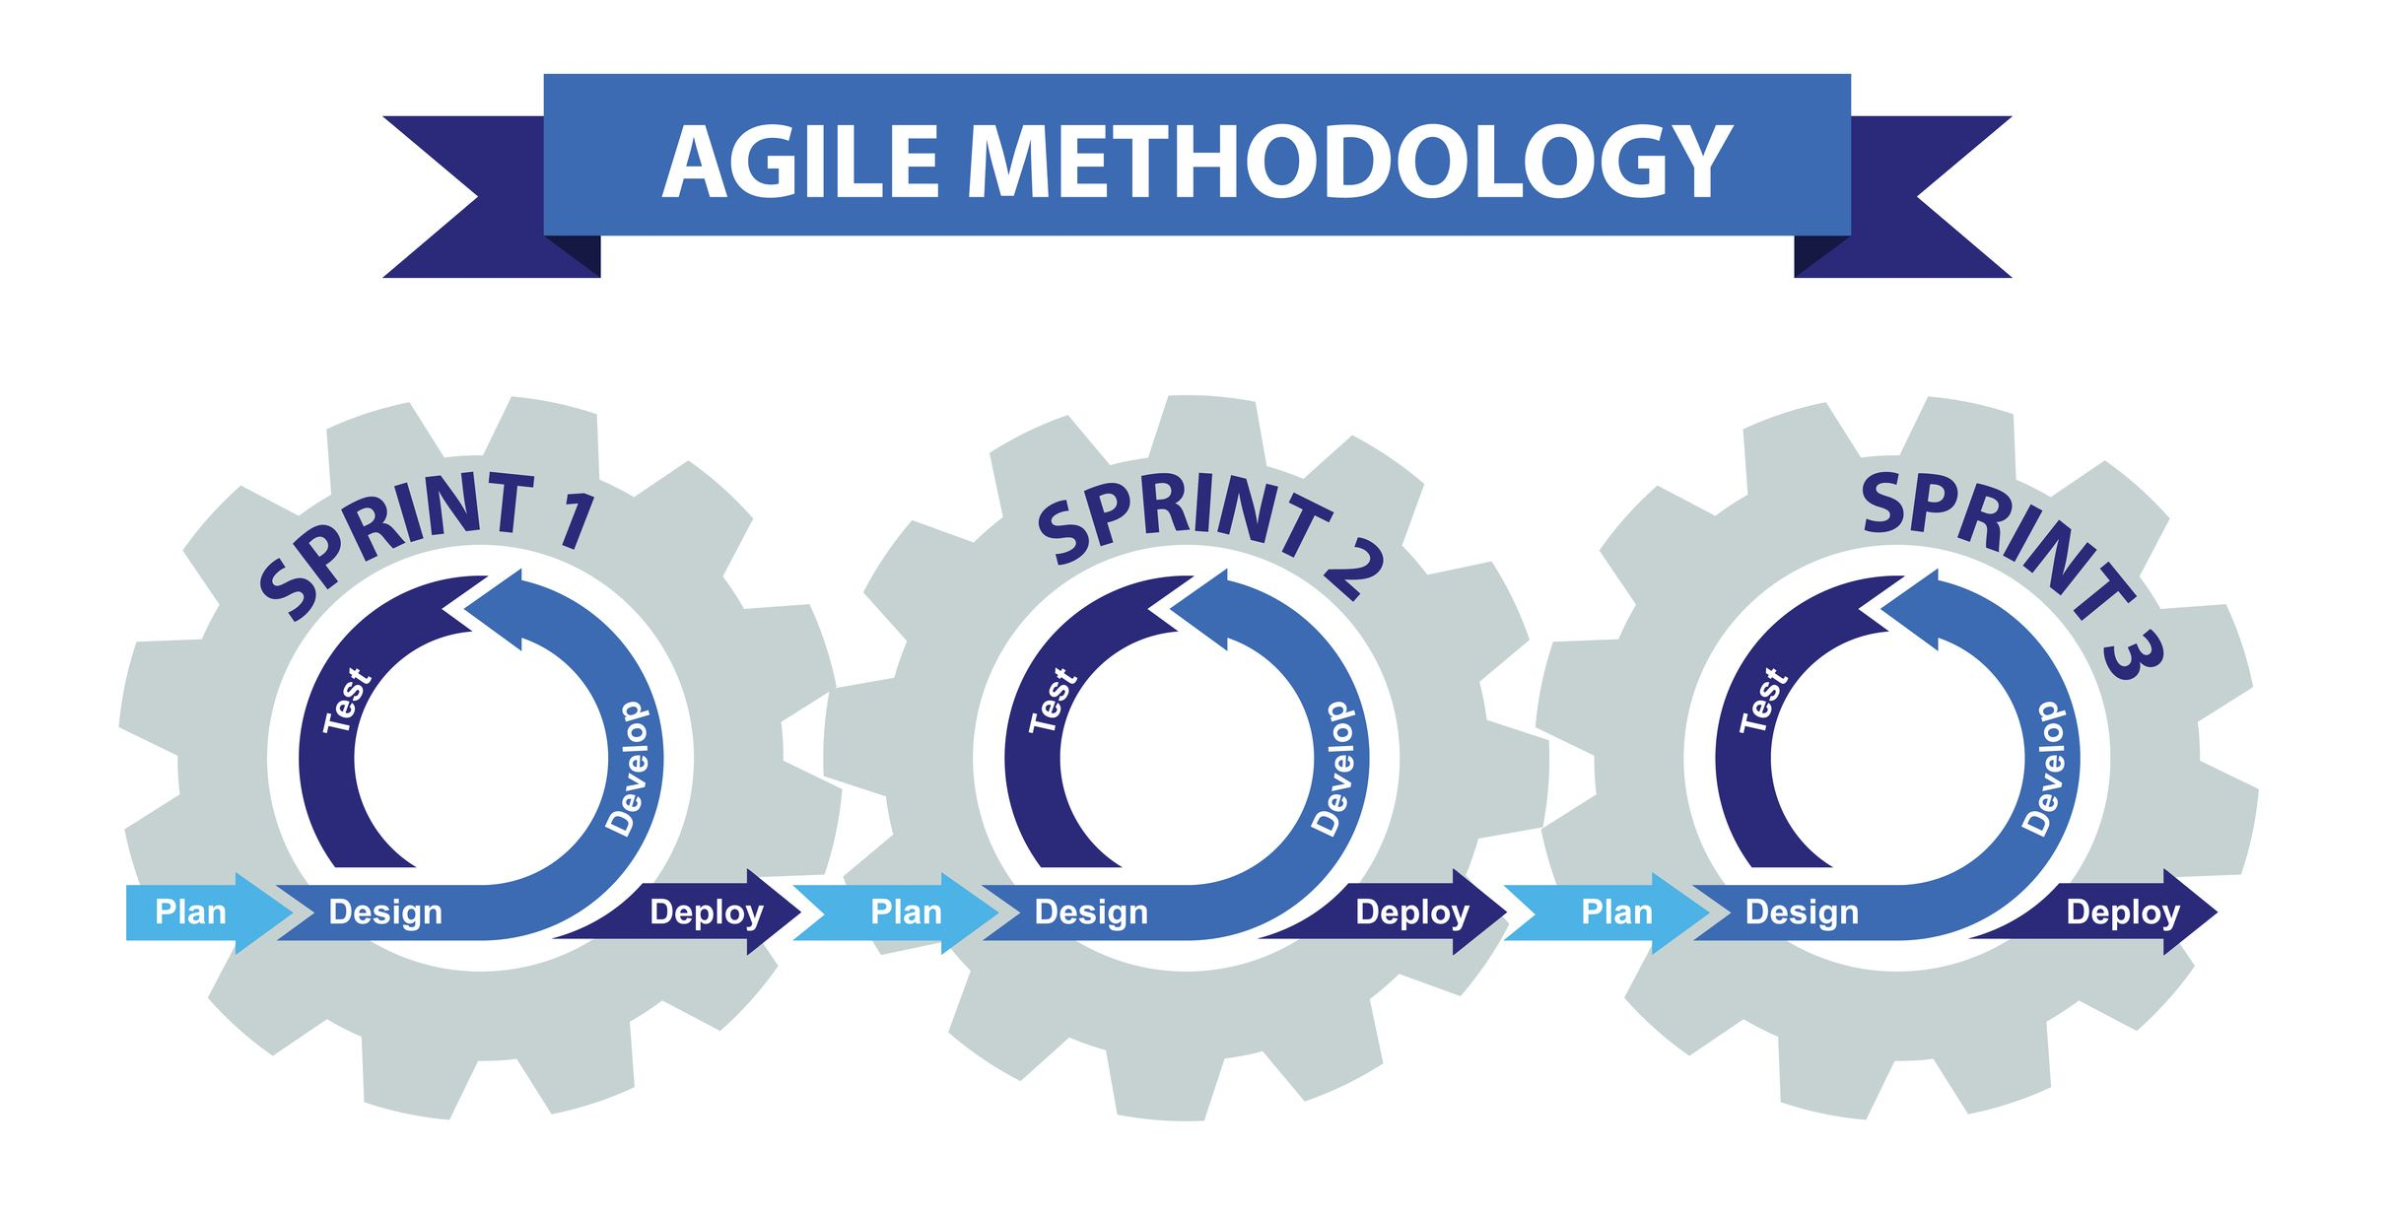
Figure 3. Scrum process framework

System scope with explanation
The main objective of the application is to provide assistance and facilities to housewives and owners of home projects or their own concerns.
In addition to marketing their products to the target class of customers, and displaying pictures of foods provided by their businesses in the best way.
And collecting and organizing a database that helps support projects similar to the idea of ​​application
To cooperate in the future with housewives to enlarge projects that have received great resonance and interest
It is recommended that the application provides after-sales service to ensure the quality and efficiency of the services provided.

Functional Requirements & Non-Functional Requirements

- The system shall allow users to create an account.
  - The user shall enter their full name.
  - The user shall enter a phone number.
  - The user shall enter their email address.
  - The user shall enter their address.
  - The user shall create a username.
1.4.1 The system shall display an error message if the username is already in use.
  - The user shall create a password for their account.
    - The system shall check the password:
      - The system shall check if the password contains at least one capital letter, at least one symbol, at least eight letters and at most sixteen letters.
      - The system shall display an error message if the password does not have at least one capital letter and one symbol.
    - The user shall confirm their password.
      - The system shall check if the two passwords match.
      - The system shall display an error message if the two passwords do not match.
  - The user shall allow the system to access their location.
- The system shall allow users and admins to login.
  - Users and admins shall enter their username and password to login to the system.
- The system shall allow users to change username or password.
  - If the user forgets the password the system shall allow user to send a new password to their emails.
  - If the user forgets the username the system shall allow user to send a new username to their emails.
- The system shall allow the user to add food to basket.
  - The system shall allow user to delete items from the basket.
  - The system shall allow user to add a note on a specific item.
  - The system shall allow the user to choose the payment method.
  - The system shall allow user to choose between home delivery or takeaway.
- The system shall allow user to add a specific food seller to favorite.
- The system shall allow user to see his last viewed food seller and last ordered seller.
- The system shall allow the user to pay online for their orders.
- The system shall allow user to give rating for food sellers.
- The system shall allow user to see other people ratings and reviews for a specific food seller.
- The system shall allow user to search by category.
- The system shall allow user to chat with the other users.
- The system shall allow user to update profile information.

Functional requirements from food sellers’ point of view:
- The system shall allow food sellers to select working days and available hours.
- The system shall allow food sellers to upload menu.
- The system shall allow food sellers to write a brief description for every dish they offer.
- The system shall allow food sellers to add images and prices for every dish.
- The system shall allow food sellers to accept and ignore orders.
- The system shall allow food sellers to cancel orders.

Functional requirements from driver point of view:
- The system shall allow driver to view assigned order.
- The system shall allow driver to accept and reject orders.
- The system shall allow driver to access the address of the customer.
- The system shall allow driver to use chat system.
  - System shall allow driver to communicate with customers.
  - System shall allow driver to communicate with food sellers.
- The system shall allow the driver to access payment to track the payments made by the customer.

Functional requirements from admins’ point of view:
- The system shall allow admin to activate and deactivate users.
  - The system shall allow admin to deactivate food seller if the food seller has low rate and negative ratings.
  - The system shall allow admin to activate and deactivate any user.

Non-Functional Requirements

- Scalability
  - The system shall be able to adapt to the increase in user request volume.
- Security
  - The system shall ensure that only authorized users gain access to it by using their username and password.
  - User shall use strong password with capital letters and symbols to avoid any threats.
- Usability
  - The system shall be user-friendly and easy to use for all ages.
- Availability
  - The system shall work twenty-four hours during the whole week for the users to use.
- Reusability
  - The system shall use back-end services to re-use it in various front-end.

Use Case Diagram with Use Cases descriptions

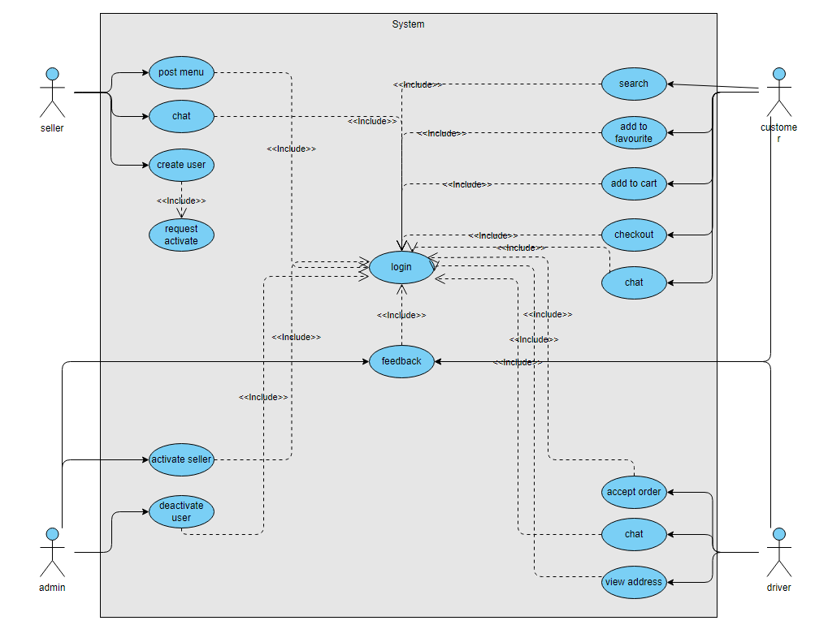
Figure 4. Use Case Diagram

Use Case Name | Create Account
Actors | Seller, Customer, Driver
Description | Users enter full name, phone number, email address, username, proper password, and location.
Pre-Condition | The user enters the create account screen.
Post-Condition | The account has been successfully created.
Flow of Activities | Actor | System
Flow of Activities | 1. Click on create an account button. 2. Fill all empty fields | 1.1 Display Sign-up form. 2.1 Validates user entries. 2.6 Create An account
Exceptions | 2.2 if the user enters a username that is already used or invalid. The system shall show error message  2.3 if the user enters an invalid password. The system shall show error message.  2.4 if the user enters an invalid phone number. The system shall show error message.
Table 1. Use Cases descriptions (Create Account)

Use Case Name | Log-in
Actors | Seller, Customer, Driver, Admin
Description | Actors enter their username and password to login to the system.
Pre-Condition | Actors must have an account
Post-Condition | Display the home page
Flow of Activities | Actor | System
Flow of Activities | 1. Enter the username and password. | 1.1 Validates user entry.  1.4 Logs User into the system.
Exceptions | 1.2 if the user enters a username is already used or invalid. The system shall show error message.  1.3 if the user enters an invalid password. The system shall show error message.
Table 2. Use Cases descriptions (Login)

Use Case Name | Forget Password or Username
Actors | Seller, Customer, Driver, Admin
Description | Actors send request to the system to change their username or password.
Pre-Condition | Actors must have an account
Post-Condition | Change password successfully.
Flow of Activities | Actor | System
Flow of Activities | 1. Send request to the system for a new password or username.  2. Reset the password as previous rules. | 1.1 Send message to the actor for reset their username or password.  2.1 Validates user entry.  2.2 Logs User into the system.
Exceptions | 1.1 The actor enters invalid username or password.
Table 3. Use Cases descriptions (Forget Password)

Use Case Name | Search
Actors | Customer
Description | Actors filters categories in the system.
Pre-Condition | The user shall be logged in to the system successfully.
Post-Condition | Display all Categories, display seller dishes
Flow of Activities | Actor | System
Flow of Activities | 1. The actor search for an category.  2. The actor select a specific category.  3. The actor select specific item. | 1.1 the system displays categories to the actor.  2.1 the system displays all seller dishes of this category.  3.1 The system shall display the chosen item.
Exceptions | 1.1 Network error, the results were not loaded successfully.
Table 4. Use Cases descriptions (Display Categories)

Use Case Name | Request to sell food
Actors | Seller, Admin
Description | Actors send request to the system to start selling food.
Pre-Condition | seller must have an account.
Post-Condition | seller account shall get activated.
Flow of Activities | Actor | System
Flow of Activities | 1. Send request to the system for a new selling account.  2. seller shall be able to start selling food on the system. | - Send message to admin to verify if the seller can start selling food.  - Admin shall check seller information.  - If it meet the requirement admin shall send acceptance .
Exceptions | - If entered information is invalid admin will reject activation of the seller.

Use Case Name | Post food menu
Actors | Seller
Description | Actors post menu
Pre-Condition | seller must have an account and should be activated.
Post-Condition | Menu shall be post on the system.
Flow of Activities | Actor | System
Flow of Activities | 1. seller shall post menu of food. | - System shall take menu .
Exceptions | - Network error.

Use Case Name | Choose seller
Actors | Customer
Description | Actor can pick a seller if the dish provided is available
Pre-Condition | The user shall be logged in to the system successfully.  Seller should be available.
Post-Condition | Seller accept your request.
Flow of Activities | Actor | System
Flow of Activities | 1. For each available Seller, actor pick a Seller.  2. For each unavailable Seller. | 1.1 the system displays the Seller is available.  2.1 the system displays that Seller is unavailable currently.
Exceptions | 1.1 Network error, the results were not loaded successfully.
Table 5. Use Cases descriptions (Pick a Handyman)

Use Case Name | Update Favorite list
Actors | Customer
Description | Actor can add and remove Seller from favorite list and check the list of favorites.
Pre-Condition | The user shall be logged in to the system successfully.
Post-Condition | Make favorite list or removed successfully.
Flow of Activities | Actor | System
Flow of Activities | 1. The actor select favorite option.  2. The actor select one favorite Seller.  3. The actor add a new Seller to favorite list.  4. The actor delete a Seller from favorite list. | 1.1 the system displays favorite list to the actor.  2.1 the system displays the Seller profile.  3.1 the system adds the Seller profile to the favorite list.  4.1 the system deletes the Seller profile from the favorite list.
Exceptions | 1.1 Network error, the results were not loaded successfully.
Table 6. Use Cases descriptions (Update List)

/

Use Case Name | Accept and reject orders
Actors | Driver, Seller
Description | The actor should be able to accept or reject orders.
Pre-Condition | The actor shall be logged in to the system successfully.
Post-Condition | Accept or reject order successfully.
Flow of Activities | Actor | System
Flow of Activities | 1. The actor press on order given.  2. The actor choose between accepting the order or rejecting it. | 1.1 the system displays order to the actor.  2.1. the system shall response to the actor choice.  2.1.1 If the actor choose to accept order he should be able to get access to the order information  2.1.2 If the actor choose to reject the order he shouldn’t be able to access the information of the order.
Exceptions | 2.1 Some information is invalid.
Table 7. Use Cases descriptions (accept and reject)

Use Case Name | Access address
Actors | Driver
Description | The Driver shall be able to access address and navigation information about the Customer.
Pre-Condition | The actor shall be logged in to the system successfully and accepted an order.
Post-Condition | Accessing order address and navigation information about the Customer.
Flow of Activities | Actor | System
Flow of Activities | 1. The actor address button of the customer.  2. The actor press on address button. | 1.1 The system shall show address information.  2.1. the system should give the driver access to the customer address.
Exceptions | 2.1 Some information is invalid.
Table 8. Use Cases descriptions (Navigation)

Use Case Name | Chat between the Driver and the Customer
Actors | Driver, Customer
Description | The Driver can chat and interact Customer.
Pre-Condition | The Driver shall be logged in to the system successfully.
Post-Condition | The Driver shall be able to chat with the Customer.
Flow of Activities | Actor | System
Flow of Activities | 1. The Driver select a Customer to chat with that has assigned order to him.  2. The Driver press chat button. | 1.1 the system displays Customer information.  2.1. the system displays chatting screen to the Driver.  2.2 the system shall allow Driver to start chatting with Customer.
Exceptions | 1.1 Network error, the results were not loaded successfully.
Table 9. Use Cases descriptions (Chat)

Use Case Name | Chat between the Driver and the Food seller
Actors | Driver, Food seller
Description | The Driver can chat and interact Food seller.
Pre-Condition | The Driver shall be logged in to the system successfully.
Post-Condition | The Driver shall be able to chat with the Customer.
Flow of Activities | Actor | System
Flow of Activities | 1. The Driver select a Food seller to chat with that has order that’s need a delivery.  2. The Driver press chat button. | 1.1 the system displays Food seller information.  2.1. the system displays chatting screen to the Driver.  2.2 the system shall allow Driver to start chatting with Food seller.
Exceptions | 1.1 Network error, the results were not loaded successfully.
Table 7. Use Cases descriptions (Chat)

Use Case Name | accessing the payments made by the customer
Actors | Driver, Food seller
Description | The Driver accessing payments made by the Customer.
Pre-Condition | The Driver shall be logged in to the system successfully.
Post-Condition | The Driver shall be able to access payments made by the Customer.
Flow of Activities | Actor | System
Flow of Activities | 1. the Driver select button that show payment details about the order accepted.  2. The Driver press Payment button. | 1.1The system display a screen with a button that route Driver to the payment details.  2.1. The system shall give access to the Driver for Payment information for the accepted order.
Exceptions | 1.1 Network error, the results were not loaded successfully.
Table 11. Use Cases descriptions (Payment)

Activity Diagram

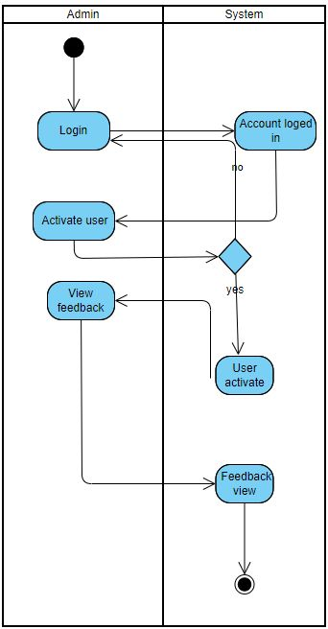
Figure 5. Activity Diagram

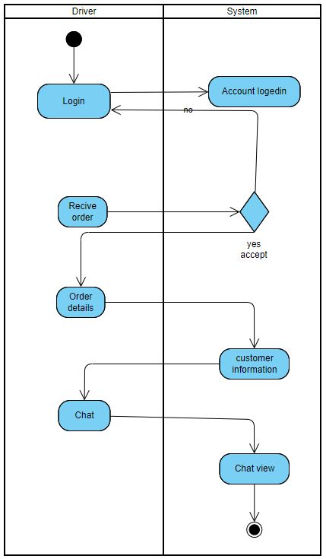
Figure 6. Activity Diagram

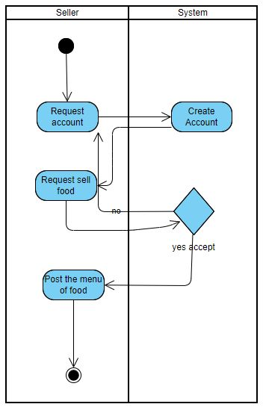
Figure 7. Activity Diagram

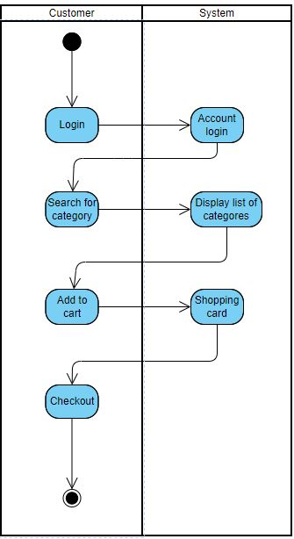
Figure 8. Activity Diagram

Chapter 3: Design

Sequence Diagrams

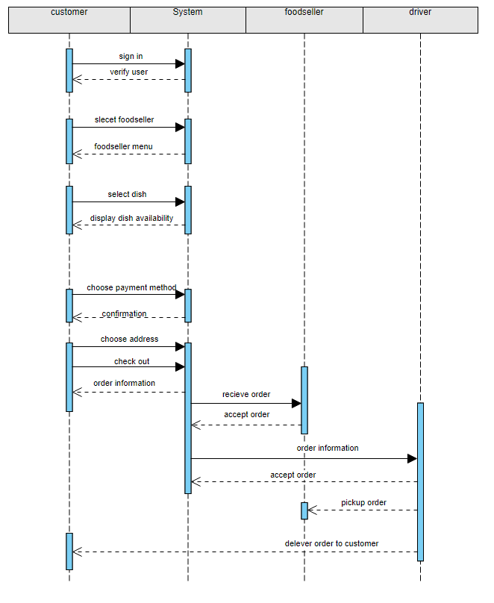

Figure 9. Sequence Diagram

Class Diagram

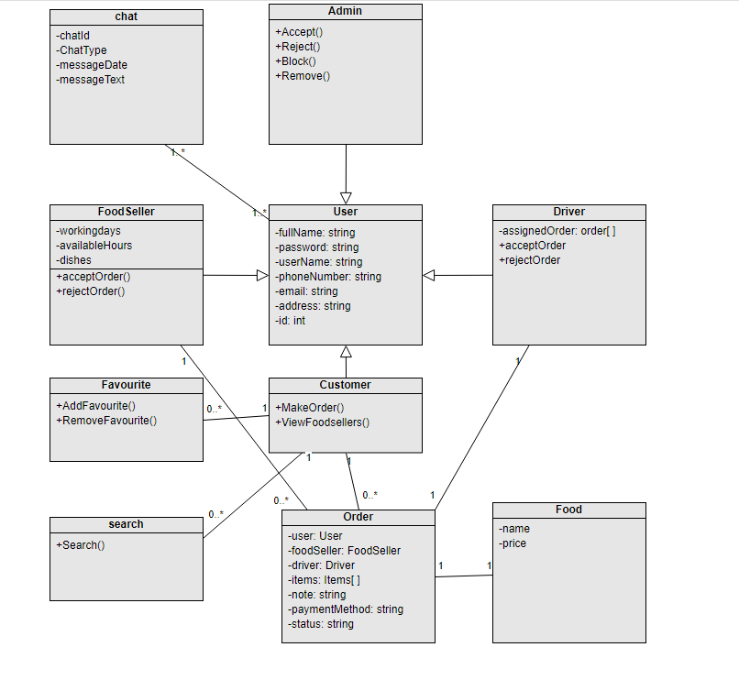
Figure 10. Class Diagram

Database ER Diagram

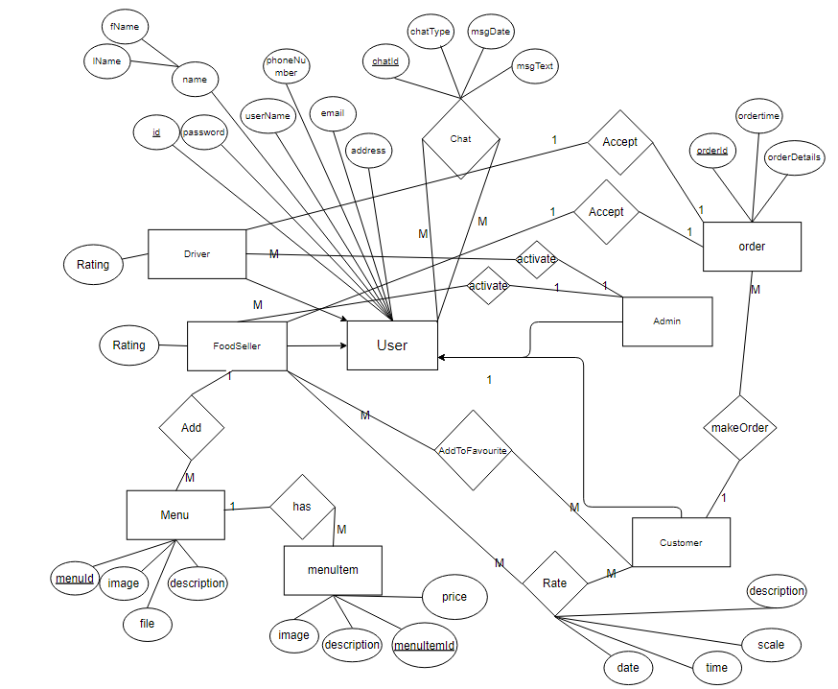
Figure 11. Database ER Diagram

Chapter 4: System Implementation

Chapter 5: System Evaluation

References
Stack Overflow
GitHub
Flutter
OpenSooq
Facebook

